Lab 24 task 3: Create a Virtual Machine Alarm to Monitor an Event
You create an alarm to monitor an event that occurs on any virtual machine in ICM-Datacenter.
1. In the navigation pane, select ICM-Datacenter and click the Configure tab in the right pane.
2. In the Alarm Definitions pane, click ADD.
The New Alarm Definition wizard starts.
3. On the Name and Targets page, configure the alarm name and target type.
a. Enter VM Suspended in the Alarm Name text box.
b. Select Virtual Machines from the Target type drop-down menu.
The target objects are all virtual machines in ICM-Datacenter.
c. Click NEXT.
4. On the Alarm Rule 1 page, define the trigger condition.
If a VM is suspended, then trigger an alarm, and show the alarm as Warning.
a. From the first drop-down menu, select VM suspended.
The VM suspended event appears under the Power and Connection State category.
b. From the select severity drop-down menu, select Show as Warning.
The alarm rule should look like this:

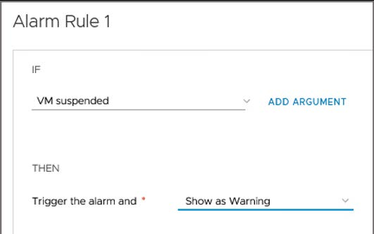

c. Click NEXT.
5. Configure the reset rule.
If the VM is powered on, then reset the alarm to normal.
a. On the Reset Rule 1 page, enable Reset the alarm to green by clicking the toggle switch.
b. Click the first drop-down menu and enter powered in the Search box.
c. Select VM powered on from the search results.
The reset rule should look like this:

d. Click NEXT.
6. On the Review page, review the alarm information.
The alarm is enabled by default.
7. Click CREATE.
8. Verify that the alarm definition is created.
a. If you cannot easily find the alarm, use the filter in the Alarm Name column and search for some or all of the alarm name.

